SMART WATER QUALITY MONITORING SYSTEM

A PROJECT REPORT

Submitted by

Student Details

FACULTY OF ENGINEERING &TECHNOLOGY
FIRST YEAR

BACHELOR OF TECHNOLOGY

IN

College Details

FEB 2025

BONAFIDE CERTIFICATE
This is to certify that [Name], a student of [Course], bearing Roll Number AG-07, has completed the project titled [Project Name] on [SDG Goal or Topic] as part of the requirements for the course.

Signature of Incharge Signature of Head of Department

DECLARATION

I, [Name], a student of [Course], hereby declare that the project titled [Project Title] is a result of my own effort.
All the sources and references used in this report have been duly acknowledged.

Date: Signature of the Student:

ACKNOWLEDGEMENT
I would like to express my sincere gratitude to everyone who supported and contributed to the successful completion of this project.

I would like to sincerely thank our Founder-Chancellor [Name], and our beloved President, [Name], for their encouragement and support throughout this project.

I would also like to thank the faculty members, professors, and especially our JR (First Year E&T), for their invaluable guidance, continuous encouragement, during this project. Their insights and suggestions were instrumental in shaping this work.

Finally, I would like to acknowledge my classmates and friends for their help in brainstorming ideas and gathering resources.
.

Name of the student

ABSTRACT

Water quality plays a crucial role in ensuring the safety of drinking water, agricultural productivity, and industrial processes. Contaminated water can have severe consequences on human health, crop yield, and machinery efficiency. Traditional water quality testing methods involve manual sampling and laboratory analysis, which are time-consuming, expensive, and impractical for real-time monitoring. To address these limitations, this project introduces a Smart Water Monitoring System designed to continuously track key water parameters pH level and temperature in real time. The system is built around an ESP8266 microcontroller, which interfaces with a pH sensor to measure acidity or alkalinity and a temperature sensor to monitor thermal conditions. These readings are processed and transmitted wirelessly to the Blynk IoT cloud platform, where users can conveniently access real-time data via a mobile application. This remote monitoring capability allows for proactive decision-making, helping users take corrective actions before water quality deteriorates. The Smart Water Monitoring System offers an efficient, cost-effective, and scalable solution for various applications, including drinking water safety, aquaculture, irrigation systems, wastewater management, and industrial cooling processes. By leveraging IoT technology, the system enhances automation, reduces manual labor, and ensures timely interventions to prevent contamination and maintain optimal water quality. This project aims to contribute to sustainable water management by providing an accessible and reliable monitoring solution, ultimately promoting environmental safety and resource conservation.

TABLE OF CONTENTS

CHAPTER NO |  | TITLE | PAGE NO
 |  | ABSTRACT | iv
 |  | LIST OF FIGURES | vii
 |  | LIST OF TABLES | viii
 |  | LIST OF ABBREVIATION | ix
1 |  | INTRODUCTION | 1
 |  | 1.1 Scope Of The Project | 2
 |  | 1.2 Project Objective | 3
 |  | 1.3 Project Outline | 4
2 |  | LITERATURE SURVEY | 3
 |  | 2.1 Introduction | 5
 |  | 2.1.1 Autonomous Water Quality Monitoring System | 6
 |  | 2.1.2 Image Processing for Water Quality Monitoring | 7
 |  | 2.1.3 Smart Sensors for Real-Time Water Quality  Monitoring | 7
3 |  | OBJECTIVE OF THE PROJECT | 9
 |  | 3.1 Real-Time Water Quality Monitoring | 9
 |  | 3.2 Automated Alert and Data Logging System | 10
4 |  | METHODOLOGY | 11
 |  | 4.1 General Introduction | 11
 |  | 4.2 Proposed System | 12
 |  | 4.3 System Architecture | 13
 |  | 4.4 Block Diagram | 15
 | 5 | SYSTEM SPECIFICATION | 18
 |  | 5.1 Software Requirement | 18
 |  | 5.1.1 Arduino IDE | 18
 |  | 5.1.2 Installation | 18
 |  | 5.1.3 Blynk App | 22
 |  | 5.2 Hardware Requirement | 24
 |  | 5.2.1 ESP8266 Microcontroller | 24
 |  | 5.2.2 Temperature Sensor | 26
 |  | 5.2.3 pH Sensor | 27
 |  | 5.2.4 Power Supply | 28
 | 6 | ANALYSIS AND DISCUSSION | 29
 | 7 | CONCLUSION AND FUTURE SCOPE | 31
 |  | 7.1 Conclusion | 31
 |  | 7.2 Future Scope | 31
 | 8 | REFERENCES | 33
 |  | APPENDIX – I | 35

LIST OF FIGURES

FIGURE  NO | NAME OF THE FIGURES | PAGE  NO
4.1 | System Architecture | 14
4.2 | Block Diagram | 16
5.1 | Choose the components to install | 18
5.2 | Choose the installation directory | 19
5.3 | The process will extract and install all the required files to execute properly the Arduino Software (IDE) | 19
5.4 | Discuss each section of the Arduino IDE display in detail. | 20
5.5 | Upload | 21
5.6 | Blynk App | 23
5.7 | ESP8266 Microcontroller | 24
5.8 | Temperature Sensor | 26
5.9 | pH Sensor | 27
6.1 | Smart Water Monitoring System | 29
6.2 | System Output | 30

LIST OF TABLES

TABLE  NO | NAME OF THE TABLES | PAGE  NO
I | Analog Pins | 24
II | Digital Pins | 24

LIST OF ABBREVATIONS

S. NO | ABBREVATION | EXPANSION
1 | pH | Potential of Hydrogen
2 | IOT | Internet of Things
3 | IDE | Integrated Development Environment
4 | GPIO | General Purpose Input/Output
5 | ALARM | Autonomous Live Animal Response Monitor
6 | CAPIM | Centre for Aquatic Pollution Identification and Management
7 | DO | Dissolved Oxygen

CHAPTER 1

INTRODUCTION
Water is a fundamental resource, essential for sustaining life, supporting ecosystems, and enabling agricultural and industrial activities. As the demand for clean and safe water continues to rise, ensuring the quality of water has become a top priority for both environmental sustainability and public health. Monitoring key water quality parameters, such as pH and temperature, is crucial for identifying potential threats to water systems and taking corrective measures. These parameters affect not only the health of aquatic organisms but also agricultural output, water treatment processes, and overall human well-being. For instance, variations in pH levels can influence the solubility of toxic metals, while temperature fluctuations can disrupt aquatic life or affect crop irrigation practices.
Traditionally, water quality monitoring has relied on manual sampling and periodic laboratory testing, which often results in delayed responses to changes in water conditions. These methods are also prone to errors, require significant human intervention, and are not conducive to real-time data analysis. Given the importance of timely and accurate water quality monitoring, a more advanced and automated approach is needed to ensure that water systems remain within safe and optimal conditions. This is where the Smart Water Monitoring System comes into play.
In this project, we propose a system that integrates modern technology to continuously monitor water quality, particularly focusing on the pH and temperature parameters. By using a pH sensor to measure acidity or alkalinity and a temperature sensor to track the water's thermal condition, the system provides accurate real-time data. The data is collected by an ESP8266 microcontroller, which processes and transmits it to a cloud platform for remote access. Through integration with Blynk IoT, the system allows users to monitor water quality from any location, using a mobile app or web interface. This cloud-based solution not only provides real-time visibility but also enables historical data tracking, helping users make informed decisions about water management.
The key advantage of this approach lies in its ability to provide continuous, uninterrupted monitoring, offering immediate insights into the water's status. For industries that rely on water quality, such as aquaculture, agriculture, and water treatment facilities, real-time monitoring ensures that any anomalies are quickly detected and addressed before they lead to larger-scale issues. The system also helps reduce the need for manual inspections and costly laboratory tests, making it a cost-effective solution for long-term water quality management.
Moreover, this Smart Water Monitoring System promotes sustainability by enabling more efficient water use and management. It empowers users to take proactive steps in maintaining water quality, whether it's adjusting pH levels for aquatic life, optimizing irrigation in agriculture, or ensuring the safety of potable water supplies. By leveraging Internet of Things (IoT) technology and cloud computing, this system represents a modern, scalable solution to the challenges of water quality monitoring, with the potential to revolutionize water management practices across various industries. Through continuous data collection and remote monitoring, it provides a more dynamic and responsive approach to safeguarding one of the most precious resources on the planet clean, safe water.

1.1 SCOPE OF THE PROJECT

The scope of this project is to develop a Smart Water Monitoring System capable of measuring the pH and temperature levels of water in real-time. The system uses a pH sensor and a temperature sensor to collect data, which is processed by an ESP8266 microcontroller. The data is then sent to the cloud through Blynk IoT, where users can access and monitor the water quality parameters via a mobile app or web interface. The project aims to provide an efficient and cost-effective solution for water quality monitoring in various applications, such as aquariums, water treatment plants, and agricultural irrigation systems.

1.2 OBJECTIVE OF THE PROJECT

The primary objective of the Smart Water Monitoring System is to develop an automated and efficient solution for continuously monitoring water quality. The system is designed to measure critical water parameters, such as pH and temperature, in real-time, ensuring that the water conditions remain optimal for different applications. By integrating the system with Blynk IoT, the collected data is transmitted to the cloud, allowing users to remotely monitor water quality from anywhere via a mobile app or web interface. This ensures that users can always stay informed about the status of their water, whether it's for aquariums, agricultural use, or industrial processes.

The system aims to provide a proactive approach to water management by offering real-time insights into pH and temperature levels. It helps ensure that the water parameters remain within the safe and desired ranges, preventing any potential issues that could arise from improper water conditions. In case of anomalies or deviations from the safe range, the system can send notifications to alert the users, allowing them to take corrective actions immediately. Additionally, the project seeks to improve water management practices in industries where consistent water quality monitoring is crucial, such as in aquaculture, water treatment, and agriculture. By offering an affordable and easily accessible solution, the system aims to enhance overall water management efficiency and contribute to sustainable practices.

1.3 PROJECT OUTLINE

The Smart Water Monitoring System is designed with a comprehensive structure that integrates hardware, software, and cloud technologies to create an efficient and reliable water quality monitoring solution. The first key component of the project is the Hardware Setup. This involves using a pH sensor and a temperature sensor, both of which are connected to an ESP8266 microcontroller. The sensors are responsible for capturing real-time data related to the pH and temperature levels of the water. Once the data is collected, the microcontroller processes this information and prepares it for transmission. The second component is Software Development, which focuses on programming the ESP8266 microcontroller to interface with the sensors and communicate the data with the Blynk IoT platform. The software ensures that the pH and temperature values are accurately captured, processed, and transmitted. The Blynk app, which is linked to the Blynk IoT platform, displays these real-time values, allowing users to remotely monitor the water quality and manage the system with ease. Cloud Integration is the third major aspect of the project. The data collected by the sensors is sent to the Blynk cloud, enabling the user to view the water quality data from anywhere through the Blynk mobile app or web dashboard. In addition to monitoring, the system can also send notifications or alerts to the user in case of any anomalies or when parameters go outside the safe range. Lastly, the project will undergo Testing and Optimization. The system will be rigorously tested to ensure the sensors provide accurate and reliable readings. The cloud integration will also be verified to ensure seamless communication between the microcontroller and the Blynk platform. Optimization will be done to ensure that the system operates efficiently and provides real-time monitoring without delay, ensuring reliability for continuous use.

CHAPTER 2

LITERATURE SURVEY
2.1 INTRODUCTION

In recent years, the integration of Radio Frequency Identification (RFID) technology has revolutionized various sectors, including attendance management and access control. RFID systems are known for their efficiency, accuracy, and convenience in automating processes that traditionally required manual intervention. The ability to quickly scan and authenticate users with RFID cards makes them ideal for applications such as student attendance, employee access, and appointment management. The convenience of RFID, combined with its seamless integration into web-based platforms, has paved the way for innovative solutions that enhance operational efficiency while reducing human error. These systems streamline administrative tasks, improve security, and enable real-time data access, making them indispensable tools in modern institutions.

The growing demand for automation in managing appointments and access control has led to the development of advanced RFID-based solutions that provide a robust alternative to traditional manual systems. RFID-based systems significantly reduce waiting times, eliminate errors associated with paper-based methods, and offer a higher level of security. By automating the process of verifying user identity, these systems ensure that only authorized individuals gain access, while simultaneously reducing the administrative burden on staff. Furthermore, with the incorporation of time-sensitive mechanisms, such as limited access windows, RFID systems provide an added layer of control, making them especially suitable for time-sensitive environments like hospitals, corporate offices, and event venues.

This paper focuses on the design and implementation of an RFID-based appointment calling system, which leverages the power of RFID technology for efficient access control and appointment management. The system is tailored to meet the needs of institutions that require secure and streamlined processes for managing appointments and controlling access to specific areas. By eliminating the need for manual check-ins and providing real-time feedback on access status, this system enhances the user experience, improves overall operational efficiency, and reduces the possibility of human error. The following sections will discuss the design, components, functionality, and advantages of this RFID-based system, highlighting its potential to transform how appointments and access control are managed in various sectors.

2.1.1 Autonomous Water Quality Monitoring System

An autonomous water quality monitoring system employing GSM communication has been developed. This system utilizes the Autonomous Live Animal Response Monitor (ALARM) toxicity biosensor, specifically designed for continuous, in-stream deployment to enable uninterrupted surveillance. Developed at the Victorian Centre for Aquatic Pollution Identification and Management (CAPIM), the system's core objective is to establish a minimal-cost, wireless water quality monitoring solution capable of continuously assessing water conditions. The system measures a comprehensive suite of physiochemical parameters crucial for evaluating freshwater health. These parameters include salinity, dissolved oxygen (DO), temperature, light intensity, pH, electrical conductivity (EC), total dissolved solids (TDS), and redox potential (ORP). Monitoring these parameters provides real-time insights into the current status of water quality and assists in the timely identification of potential pollution sources. A key feature of this system is its reliance on low-cost sensors and open-source hardware, contributing to a significantly lower overall implementation cost compared to traditional water quality monitoring methods. This cost-effectiveness makes the system more accessible for wider deployment and continuous monitoring, particularly in resource-limited settings. Furthermore, the continuous monitoring capabilities of the system allow for the detection of transient pollution events that might be missed by less frequent sampling methods. The GSM communication module enables remote data access and alerts, facilitating timely responses to water quality issues.

2.1.2 Image Processing for Water Quality Monitoring

The use of image processing technology has emerged as a valuable approach in water quality monitoring . One such method focuses on analyzing fish behavior as an indicator of water quality. A system has been developed that leverages image processing and automatic gesture recognition of fish using fuzzy inference. The process begins by establishing an image background model using the W4 method, followed by background subtraction to isolate the fish profile. Once the center-of-gravity of the fish is determined, real-time characteristic information, including position, movement trajectory, and speed, can be extracted. This information serves as input for a fuzzy inference system. Through a set of predefined rules, the fuzzy system analyzes this data and generates an output value indicative of water quality. In this particular study, Zebra fish and Common Goldfish were selected as model organisms. These fish were observed both in and out of water, under varying concentrations of specific agents, using different recording devices to capture their responses. This approach allows for the assessment of how fish behavior changes in response to different water quality conditions, providing a potentially sensitive and rapid method for detecting pollution or other environmental stressors.

2.1.3 Smart Sensors for Real-Time Water Quality Monitoring

A smart sensor system employing ZigBee communication has been developed for real-time water quality monitoring . This system is designed to measure key physiochemical parameters relevant to water quality assessment, including flow rate, temperature, pH, conductivity, and redox potential. These parameters are crucial for identifying pollutants in various water bodies such as rivers and lakes. The sensors are connected to a microcontroller-based measuring node, which is responsible for data processing and evaluation. ZigBee transmitter and receiver modules facilitate communication between the measuring node and a notification node. The notification hub displays the sensor readings and triggers an audio alert when any of the measured parameters reach critical levels. Rigorous calibration tests have been conducted to ensure the accuracy and reliability of each component within the monitoring system. The sensors operate within their specified precision ranges, providing reliable measurements. The measuring node transmits the acquired data to the notification node via ZigBee, enabling both visual display of the readings and the generation of the audio alarm. The results of testing demonstrate the system's capability to accurately measure the targeted physiochemical parameters, as well as its effectiveness in data processing, transmission, and display.

CHAPTER 3

OBJECTIVE OF THE PROJECT

The primary objective of the Smart Water Monitoring System is to develop an automated solution for monitoring water quality by continuously measuring pH and temperature levels in real time. Ensuring water quality is essential for various applications, including drinking water, agriculture, aquaculture, and industrial processes. Traditional monitoring methods require manual sampling and laboratory analysis, which can be time-consuming, labor-intensive, and prone to inaccuracies. This project aims to overcome these limitations by implementing a smart, IoT-based monitoring system that provides real-time data, reduces human effort, and improves efficiency.
By utilizing an ESP8266 microcontroller, pH sensor, and temperature sensor, the system continuously collects water quality data and transmits it to the Blynk IoT cloud platform. Users can monitor the data remotely through a mobile app or web interface, enabling them to take immediate action if water conditions deviate from the desired range. Additionally, the system enhances decision-making processes by providing historical data analysis, helping users maintain optimal water conditions over time.

3.1 REAL-TIME WATER QUALITY MONITORING

One of the key objectives of this project is to enable real-time water quality monitoring using an automated IoT-based system. Conventional methods involve periodic sampling, which may result in delayed responses to water quality fluctuations. In contrast, this system ensures continuous monitoring, providing immediate alerts if any irregularities in pH or temperature are detected. The use of Blynk IoT integration allows users to access water quality data anytime, anywhere, ensuring timely interventions to prevent contamination or damage to aquatic ecosystems.

By leveraging the ESP8266 microcontroller, the system processes data from sensors and transmits it to the cloud, eliminating the need for manual intervention. This ensures accurate and up-to-date information, making the monitoring process more efficient and reliable. Real-time tracking is particularly beneficial in applications such as aquaculture, where maintaining stable water conditions is essential for the health of aquatic life, and in agricultural irrigation, where pH and temperature fluctuations can directly impact crop growth

3.2 AUTOMATED ALERT AND DATA LOGGING SYSTEM

Another critical aspect of the project is the implementation of an automated alert and data logging system to enhance user awareness and facilitate long-term water quality management. The system is designed to send instant alerts via the Blynk app when the pH or temperature levels deviate from the pre-set safe range. These notifications allow users to take prompt corrective actions, preventing potential risks such as water contamination, crop damage, or the disruption of industrial processes.

Additionally, the system continuously logs historical data, which can be analyzed to detect patterns or trends in water quality over time. This feature is particularly useful for industries that require long-term monitoring, such as water treatment plants, fish farming, and environmental studies. The stored data helps users make informed decisions, optimize resource usage, and implement predictive maintenance strategies. By automating data collection and alerts, the Smart Water Monitoring System provides a proactive approach to water management, ensuring sustainability and efficiency.

CHAPTER 4
METHODOLOGY

4.1 GENERAL INTRODUCTION

The methodology of the Smart Water Monitoring System outlines the systematic approach employed to design, develop, and implement the system for real-time monitoring of critical water quality parameters. This methodology encompasses a structured, multi-stage process, beginning with sensor selection and calibration, progressing through hardware integration and firmware development, and culminating in cloud connectivity and user interface design. The core objective is to create a robust, reliable, and user-friendly system that provides accurate and timely water quality information.
The system integrates two key sensors: a pH sensor to measure the acidity or alkalinity of the water, and a temperature sensor to monitor water temperature. These sensors are interfaced with an ESP8266 microcontroller, chosen for its Wi-Fi capabilities and processing power, which acts as the central data acquisition and processing unit. The ESP8266 reads the analog signals from the sensors, converts them into digital values, and performs any necessary signal conditioning or calibration adjustments.
The processed data is then transmitted to the Blynk IoT cloud platform. Blynk was selected for its ease of use, mobile app interface, and data visualization capabilities. The data is sent wirelessly from the ESP8266 to the Blynk cloud using the microcontroller's built-in Wi-Fi. On the Blynk platform, the received data is stored, visualized in real-time on dashboards, and made accessible to users through a dedicated mobile application or web browser.
This section details the step-by-step implementation of the proposed system. This includes a discussion of the specific hardware components chosen and the rationale behind their selection, the software development process for the ESP8266 firmware, the configuration of the Blynk platform, and the design of the user interface. Crucially, the methodology also addresses the calibration procedures used to ensure sensor accuracy, the data processing techniques employed to filter noise and improve reliability, and the implementation of alert mechanisms to notify users of any deviations in water quality parameters beyond pre-defined thresholds. The methodology emphasizes a modular design approach, allowing for easy expansion of the system with additional sensors or functionalities in the future. Finally, it outlines the testing and validation procedures used to evaluate the performance and accuracy of the developed system.

4.2 PROPOSED SYSTEM

The proposed Smart Water Monitoring System offers a significant advancement in water quality management by leveraging the power of the Internet of Things (IoT) to automate the continuous monitoring of pH and temperature levels. Traditional water quality assessment often relies on periodic manual sampling and laboratory analysis, which can be time-consuming, resource-intensive, and may not capture transient events or sudden changes in water quality. In contrast, the proposed system provides a real-time, automated solution that addresses these limitations. By continuously monitoring key parameters like pH and temperature, the system provides immediate insights into water conditions, enabling proactive responses to potential issues.

The core of the system is the integration of reliable pH and temperature sensors with the ESP8266 microcontroller. This microcontroller serves as the central processing unit, acquiring sensor readings, performing necessary signal conditioning, and managing data transmission. The ESP8266's built-in Wi-Fi capability is crucial for seamless data transfer to the Blynk IoT cloud platform. Blynk provides the infrastructure for data storage, visualization, and remote access through a user-friendly mobile application. This cloud-based approach allows users to monitor water quality from anywhere with an internet connection, eliminating the need for on-site presence.

Beyond simple monitoring, the system incorporates an intelligent alert mechanism. Pre-defined thresholds for pH and temperature are established, and any deviation beyond these limits triggers instant notifications to the user's mobile device. This real-time alert system is essential for prompt intervention, minimizing potential damage or losses in applications like aquaculture or industrial processes. Furthermore, the system logs historical data, providing a valuable resource for trend analysis. By examining historical patterns, users can gain a deeper understanding of water quality dynamics, identify potential long-term issues, and optimize water management strategies. The combination of real-time monitoring, automated alerts, and historical data logging makes this system a powerful tool for diverse applications, ranging from aquaculture and agriculture to industrial water treatment and environmental monitoring. This technology promotes more efficient and sustainable water management practices by providing timely and accurate information for informed decision-making.

4.3 SYSTEM ARCHITECTURE

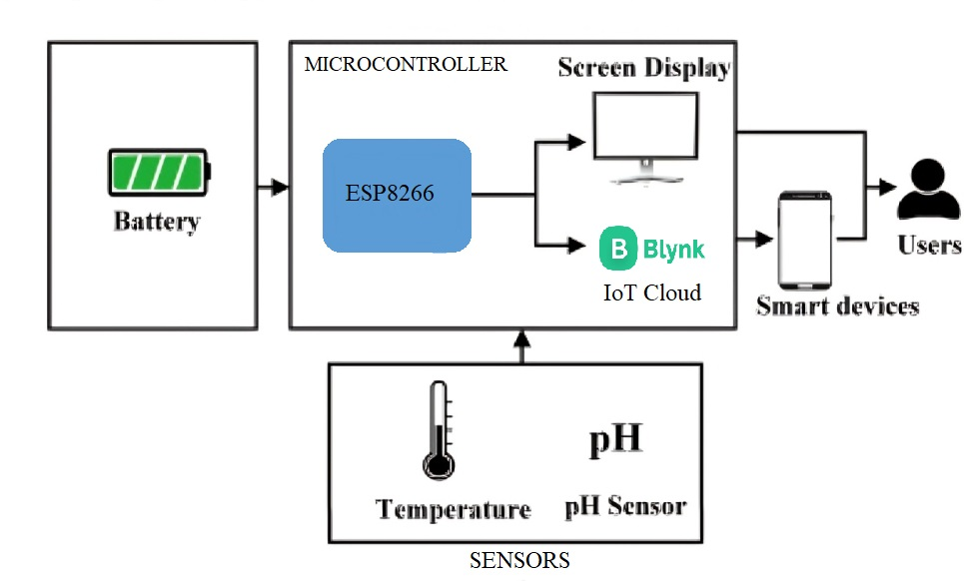
The System architecture of the Smart Water Monitoring System is not merely a structural organization; it's a deliberate design choice that underpins the system's functionality, robustness, and scalability. This layered approach, encompassing sensor, processing, communication, and user interface layers, allows for specialization and abstraction, simplifying development and maintenance. Each layer performs a specific set of tasks, contributing to the overall system's goals. The sensor layer, the point of contact with the physical environment, is crucial for accurate data acquisition. The selection and implementation of high-quality pH and temperature sensors directly impact the reliability of the entire system. The processing layer, centered around the ESP8266, acts as the system's brain. It's not just a data conduit; it's an intelligent processor, converting raw sensor readings into meaningful digital information, potentially performing calibration or filtering, and preparing the data for transmission. The communication layer, enabled by the ESP8266's Wi-Fi capabilities, is the bridge to the digital world. It's what empowers remote access and real-time monitoring, the hallmarks of an IoT-based solution. This wireless communication eliminates the constraints of physical connections, allowing for flexible deployment and remote management. Finally, the user interface layer, presented through the Blynk platform, is where the user interacts with the system. It transforms complex data into easily understandable visualizations, enabling informed decision-making. This layer is not just about displaying data; it's about empowering the user with actionable insights, historical trends, and timely alerts. The interplay between these layers, governed by well-defined protocols, ensures a smooth and efficient flow of information, from the initial sensing of water quality parameters to the final presentation of actionable insights to the user. This architecture is designed not only for current needs but also for future expansion, allowing for the integration of additional sensors, functionalities, or even more sophisticated data analysis techniques.

Figure 4.1 System Architecture
4.4 BLOCK DIAGRAM :

The block diagram, Sensors (pH & Temperature) → ESP8266 Microcontroller → Wi-Fi Module → Blynk IoT Cloud → User Interface (Mobile/Web Dashboard), visually encapsulates the data pathway and component interactions within the Smart Water Monitoring System. This simplified representation clearly illustrates the flow of information, starting with the initial sensing of water quality parameters and culminating in the presentation of that data to the user. At the beginning of the chain, the pH and temperature sensors act as the primary data acquisition units, converting physical properties of the water into measurable electrical signals. These signals, representing the acidity/alkalinity and temperature of the water, are then fed into the ESP8266 microcontroller. The ESP8266 serves as the system's processing hub, receiving the analog sensor signals, converting them to digital values, and potentially performing necessary calibrations or filtering. Integrated within the ESP8266 is the Wi-Fi module, which acts as the communication bridge, transmitting the processed data wirelessly to the Blynk IoT Cloud. This cloud platform is a critical component, providing not only data storage but also the infrastructure for real-time data visualization and remote access. The Blynk cloud receives the data stream from the ESP8266 and makes it accessible to the user through the user interface, which can be a mobile application or a web dashboard. This user interface is the final point in the data pathway, where the user can view real-time readings, historical trends, and receive alerts based on pre-defined thresholds. The block diagram, therefore, is more than just a visual aid; it's a conceptual roadmap of the system's operation, highlighting the essential components and their interconnected roles in achieving real-time, automated water quality monitoring. This streamlined data flow, from sensor to cloud to user, is what makes the system an innovative and practical solution for diverse applications.

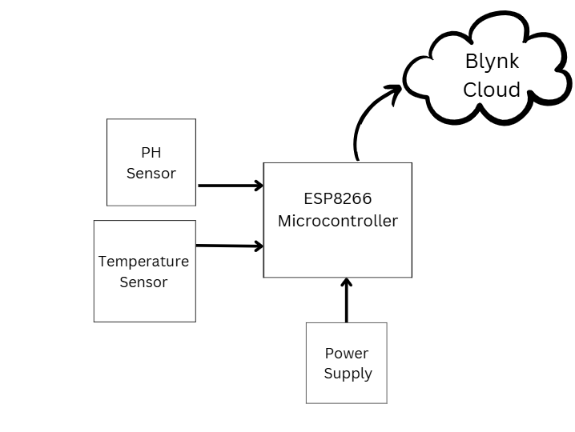
Figure 4.2 Block Diagram

Sensors (pH & Temperature):

The system's foundation lies in its ability to accurately measure key water quality parameters. This is achieved through the use of specialized sensors. The pH sensor measures the hydrogen ion concentration in the water, providing a reading of its acidity or alkalinity. This is a crucial parameter for assessing water quality as it influences various biological and chemical processes. The temperature sensor measures the water's temperature, another vital indicator of water health. Temperature affects the solubility of gases, the rate of chemical reactions, and the survival of aquatic organisms. These two sensors, working in tandem, provide a basic yet essential snapshot of the water's condition. They generate analog voltage signals proportional to the measured pH and temperature levels.

ESP8266 Microcontroller:

The analog signals from the sensors are fed into the ESP8266 microcontroller, the system's central processing unit. This microcontroller is chosen for its low cost, built-in Wi-Fi capabilities, and sufficient processing power for this application. The ESP8266 performs several crucial tasks: First, it converts the analog signals from the sensors into digital values using its built-in Analog-to-Digital Converter (ADC). This digital conversion is essential for further processing and transmission of the data. Second, the ESP8266 may perform signal conditioning or calibration adjustments to enhance the accuracy and reliability of the sensor readings. Finally, it formats the processed data into a suitable format for transmission to the cloud.

Blynk IoT Cloud:

The Blynk IoT Cloud acts as the central hub for data storage, processing, and user access. It receives the data transmitted by the ESP8266 via Wi-Fi. Blynk provides a platform for storing the data securely and making it accessible through a user-friendly interface. The cloud also facilitates real-time data visualization, allowing users to monitor the pH and temperature levels remotely. Furthermore, Blynk allows for the configuration of alerts and notifications, which can be triggered when the measured parameters exceed pre-defined thresholds.

CHAPTER 5

SYSTEM SPECIFICATION

5.1 SOFTWARE REQUIREMENT

5.1.1 ARDUINO IDE
The open-source Arduino Software (IDE) makes it easy to write code and upload it to the board. It runs on Windows, Mac OS X, and Linux. The environment is written in Java and based on Processing and other open-source software. This software can be used with any Arduino board.
5.1.2 INSTALLATION
In this project Arduino 4.0is installed. We can choose between the Installer (.exe) and the Zip packages. If you use the first one that installs directly everything you need to use the Arduino Software (IDE), including the drivers. With the Zip package you need to install the drivers manually. The Zip file is also useful if you want to create a portable installation. When the download finishes, proceed with the installation and please allow the driver installation process when you get a warning from the operating system.

Figure 5.1 Choose the components to install

Figure 5.2 Choose the installation directory ( suggested to keep the default one)

Figure 5.3 The process will extract and install all the required files to execute properly the Arduino Software (IDE)

Softwareserial Library
The Arduino hardware has built-in support for serial communication on pins 0 and 1 (which also goes to the computer via the USB connection). The native serial support happens via a piece of hardware (built into the chip) called a UART. This hardware allows the Atmega chip to receive serial communication even while working on other tasks, as long as there room in the 64 byte serial buffer. The SoftwareSerial library has been developed to allow serial communication on other digital pins of the Arduino, using software to replicate the functionality (hence the name "SoftwareSerial"). It is possible to have multiple software serial ports with speeds up to 115200 bps. A parameter enables inverted signaling for devices which require that protocol. To use this library,we have to write ,

#include <SoftwareSerial.h>

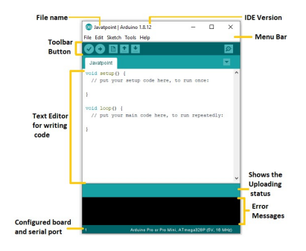
The Arduino IDE will appear as:

Figure 5.4 Let's discuss each section of the Arduino IDE display in detail.

Toolbar Button
The icons displayed on the toolbar are New, Open, Save, Upload, and Verify.
It is shown below:
Upload
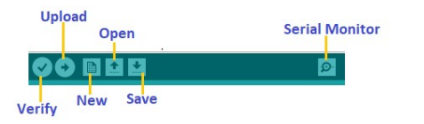

Figure 5.5 Upload

The Upload button compiles and runs our code written on the screen. It further uploads the code to the connected board. Before uploading the sketch, we need to make sure that the correct board and ports are selected. We also need a USB connection to connect the board and the computer. Once all the above measures are done, click on the Upload button present on the toolbar. The latest Arduino boards can be reset automatically before beginning with Upload. In the older boards, we need to press the Reset button present on it. As soon as the uploading is done successfully, we can notice the blink of the Tx and Rx LED. If the uploading is failed, it will display the message in the error window. We do not require any additional hardware to upload our sketch using the Arduino Bootloader. A Bootloader is defined as a small program, which is loaded in the microcontroller present on the board. The LED will blink on PIN 13.
Open
The Open button is used to open the already created file. The selected file will be opened in the current window.
Save
The save button is used to save the current sketch or code.
New
It is used to create a new sketch or opens a new window.
Verify
The Verify button is used to check the compilation error of the sketch or the written code.
Serial Monitor
The serial monitor button is present on the right corner of the toolbar. It opens the serial monitor.
It is shown below:
When we connect the serial monitor, the board will reset on the operating system Windows, Linux, and Mac OS X. If we want to process the control characters in our sketch, we need to use an external terminal program. The terminal program should be connected to the COM port, which will be assigned when we connect the board to the computer.
Open Recent
The Open Recent button contains the list of the recent sketches.
Sketchbook
It stores the current sketches created in the Arduino IDE software. It opens the selected
sketch or code in a new editor at an instance.
Examples
It shows the different examples of small projects for a better understanding of the IDE and
the board. The IDE provides examples of self-practice.

5.1.3 BLYNK APP

The Blynk app is a highly versatile and user-friendly Internet of Things (IoT) platform that allows developers to create and manage IoT-based applications effortlessly. It provides a graphical interface to control and monitor hardware devices such as microcontrollers, sensors, and actuators. The app supports various communication protocols, including Wi-Fi, Bluetooth, and Ethernet, making it adaptable to numerous IoT projects. The core functionality of the Blynk app lies in its ability to connect the physical world with digital dashboards. By using the Blynk IoT server, devices communicate with the app to send and receive data in real time. The app's interface is customizable, offering widgets like buttons, sliders, and graphs to create a user-friendly control panel. For example, in a vehicle accident detection system, the Blynk app is used to receive real-time notifications of accidents, including the vehicle's location via GPS data transmitted through the ESP8266 microcontroller. The app allows users to visualize data, send alerts, and respond quickly to emergencies, ensuring efficient monitoring and control of IoT-enabled systems. The app's cross-platform compatibility, ease of integration, and scalability make it a popular choice for IoT applications ranging from home automation to industrial monitoring and smart transportation systems.
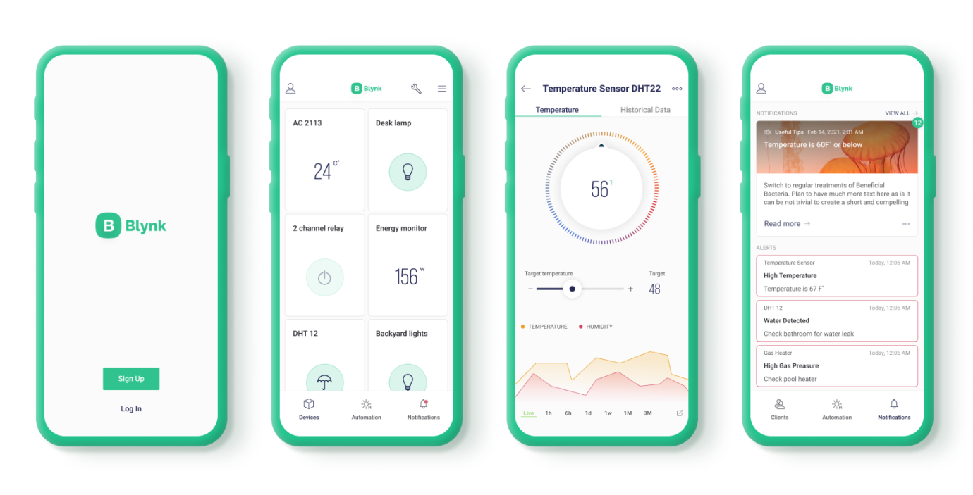

Figure 5.6 Blynk App

5.2 HARDWARE REQUIREMENT

5.2.1 ESP8266 MICROCONTROLLER :

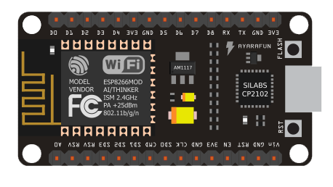

Figure 5.7 ESP8266 Microcontroller
Processor :
The ESP8266 is a 32-bit microcontroller based on a RISC processor, designed for low-cost and low-power applications. It operates at clock speeds of up to 80 MHz, offering sufficient processing power for a wide range of tasks. The processor features a single-core design and integrates both Wi-Fi capabilities and several GPIO (General Purpose Input/Output) pins for interfacing with external devices. It is capable of handling communication protocols like TCP/IP, which makes it ideal for IoT projects, providing the ability to connect devices to the internet or local networks.

Power Supply:
The Arduino Nano can be powered by either the USB port or alternatively via VIN. The input supply of VIN is regulated by an LDO so the supply is limited to 5V for the optimal functioning of the board. There is also another regulator which limits the voltage to 3.3V for powrering the components with low voltage requirements.

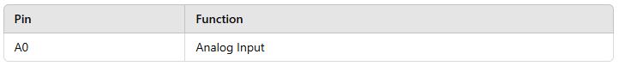
Analog Pins :
Table I. Analog Pins

Analog Pin (A0): The ESP8266 has a single analog input pin (A0), which can read values in the range of 0 to 1V (typically 0 to 1023 on a 10-bit ADC).

Digital pins :

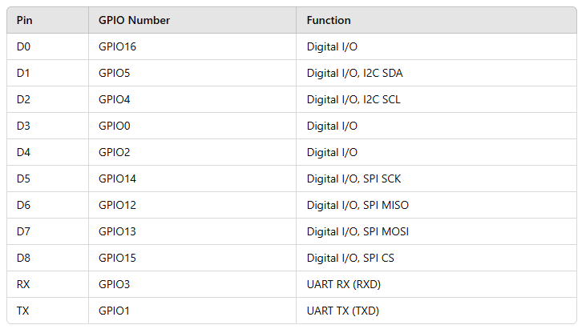
Table II. Digital Pin

Digital Pins (GPIO): The ESP8266 has several digital pins (D0 to D8) that can be used for general-purpose I/O. Some of these pins also serve specific functions like I2C, SPI, and UART.

5.2.2 TEMPERATURE SENSOR:

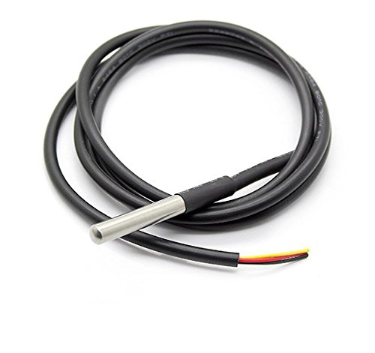

Figure 5.8 Temperature Sensors

Water temperature sensors are essential tools in diverse fields, from environmental science to industrial applications. These sensors operate by detecting temperature-induced changes in a material's physical properties. Common types include thermistors (temperature-sensitive resistors), thermocouples (utilizing the Seebeck effect), and RTDs (resistance temperature detectors). Each type leverages a different principle to translate temperature variations into measurable signals, such as changes in resistance or voltage. Regardless of the specific mechanism, the core function remains the same: to provide an accurate and reliable measurement of water temperature. This measurement is vital because temperature significantly influences physical, chemical, and biological processes in water.

5.2.3 pH SENSOR:
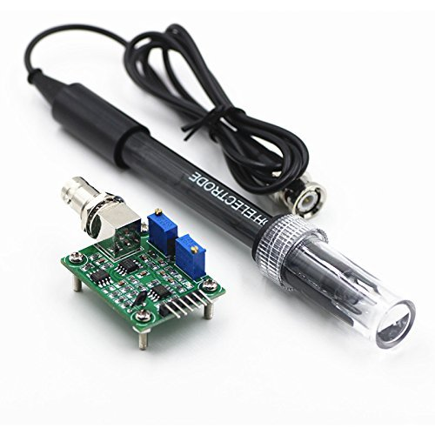

Figure 5.9 pH Sensor

pH sensors are critical tools for measuring the acidity or alkalinity of a solution. They operate based on the principle of measuring the concentration of hydrogen ions (H+) in a solution. The pH scale, ranging from 0 to 14, quantifies this concentration, with lower pH values indicating higher acidity (more H+ ions) and higher pH values indicating higher alkalinity (fewer H+ ions). Most pH sensors utilize a glass electrode, which is sensitive to H+ ions. This electrode is immersed in the solution being measured, and a potential difference develops between the glass electrode and a reference electrode, which is also in contact with the solution. This potential difference is directly related to the pH of the solution. The sensor measures this potential difference and converts it into a pH reading. Modern pH sensors often incorporate temperature compensation to ensure accurate readings across varying temperatures, as temperature can affect the sensor's response. Accurate pH measurement is essential in various fields, including water quality monitoring, as pH plays a vital role in chemical reactions, biological processes, and the overall health of aquatic ecosystems.
5.2.4 POWER SUPPLY:
In microcontroller-based projects, power supplies often include voltage regulators to ensure stable and noise-free operation. For example, an ESP8266-based system typically requires a 3.3V power supply, while other modules like sensors or actuators may operate at 5V. A common configuration involves using a regulated DC power supply or voltage converters (e.g., 7805 or LM317) to provide multiple voltage levels.
Modern power supplies include features like overload protection, thermal shutdown, and short-circuit prevention to enhance reliability. In IoT applications, compact and efficient power supplies, such as USB adapters or lithium-polymer (LiPo) batteries, are often used to ensure continuous and portable operation. The choice of a power supply is critical as it directly affects the system's performance, stability, and longevity.

CHAPTER 6

ANALYSIS AND DISCUSSION

OVERVIEW OF SMART WATER MONITORING SYSTEM

Figure 6.1 Smart Water Monitoring System
Smart Water Monitoring System employing an ESP8266 microcontroller, pH and temperature sensors, and the Blynk cloud platform, the analysis and discussion section would focus on interpreting the real-time data collected and its implications for water quality. This section would begin by analyzing the trends and patterns observed in the pH and temperature readings. For example, are there any correlations between changes in temperature and pH? Are there any diurnal variations in these parameters? Any significant deviations from expected or baseline values would be highlighted and investigated. The discussion would then delve into the potential causes of these observed changes. Factors such as pollution sources, industrial discharge, agricultural runoff, or natural processes could be considered. Comparison of the collected data with established water quality guidelines or standards would be crucial in assessing the health of the water body. If the system is deployed in a specific environment, such as an aquaculture farm or an industrial setting, the analysis would focus on the relevance of the observed changes to that particular context. For instance, how might fluctuations in pH and temperature affect fish health in aquaculture? The discussion would also address the performance of the system itself, considering factors like sensor accuracy, data transmission reliability, and the user-friendliness of the Blynk interface. Any limitations of the system, such as sensor drift or potential sources of error, would be acknowledged. Finally, the analysis and discussion section would conclude by summarizing the key findings and highlighting the practical implications of the real-time water quality data. This might include recommendations for water treatment, pollution control, or further investigation. The section would also emphasize the benefits of using an IoT-based approach for water quality monitoring, such as its ability to provide continuous, real-time data and facilitate timely interventions.

Figure 6.2 System Output

CHAPTER 7

CONCLUSION AND FUTURE SCOPE

7.1 CONCLUSION

The Smart Water Monitoring System, utilizing an ESP8266 microcontroller, pH and temperature sensors, and the Blynk IoT platform, has demonstrated its effectiveness in providing real-time, automated water quality monitoring. The system successfully collected and transmitted pH and temperature data to the Blynk cloud, enabling remote access and visualization through a user-friendly interface. The real-time data provided by the system allows for immediate assessment of water quality conditions, facilitating timely responses to any detected anomalies or deviations from established thresholds. This automated approach offers significant advantages over traditional manual sampling methods, which are often time-consuming, resource-intensive, and may miss transient events. The system’s ability to continuously monitor water quality parameters makes it a valuable tool for various applications, including aquaculture, agriculture, industrial water treatment, and environmental monitoring. The use of low-cost components, such as the ESP8266, and the readily available Blynk platform makes the system accessible and potentially deployable on a wider scale. The successful implementation of this system demonstrates the potential of IoT-based solutions for improving water resource management and ensuring water quality.

7.2 FUTURE SCOPE

While the current system effectively monitors pH and temperature, several enhancements and expansions can be explored in future development. Integrating additional sensors to monitor other crucial water quality parameters, such as dissolved oxygen, turbidity, conductivity, and specific pollutants, would provide a more comprehensive assessment of water health. Implementing advanced data analytics and machine learning algorithms could enable predictive modeling of water quality changes, allowing for proactive interventions and more effective water management strategies. Exploring the use of alternative communication protocols, such as LoRaWAN or NB-IoT, could extend the system's range and improve its performance in remote or challenging environments. Developing a more sophisticated user interface with advanced features, such as data visualization, trend analysis, and automated report generation, would further enhance the system's usability and value. Integrating the system with other environmental monitoring platforms or databases could facilitate data sharing and collaboration among researchers and stakeholders. Furthermore, exploring the potential for incorporating control mechanisms, such as automated water treatment or alarm systems, could transform the system from a monitoring tool into an active water management solution. Finally, field testing and validation of the system in real-world scenarios are essential for assessing its performance and identifying areas for improvement.

CHAPTER 8

REFERENCES

ChoZinMyint, Lenin Gopal and Yan Lin Aung,”Reconfigurable smart water quality monitoring system in iot environment”, IEEE Internatinal Conference on Information Systems(ICIS),978-1-5090-5507-4/17,May 2017.

Sona Pawara, Siddhi Nalam, Saurabh Mirajkar,Shruti GujarVaishali Nagmoti,” Remote Monitoring of Waters Quality from Reservoirs”, 2017 2nd International Conference for Convergence in Technology (I2CT).

Francesco A, Fliippo A, Carlo G C ,Anna M L,”A Smart sensor network for sea water quality monitoring, IEEE Sensors J 15(5):2514-2522,May 2015.

S. P. Gorde, M. V. Jadhav “Assessment of Water Quality Parameters: A Review”, S. P. Gorde et al Int. Journal of Engineering Research and Applications ,ISSN : 2248-9622, Vol. 3, Issue 6, Nov-Dec 2013, pp.2029-2035.

S. Geetha and S. Gouthami,” Internet of things enabled real time water quality monitoring system”, Springer open (2017) 2:1 DOI 10.1186/s40713-017-0005-y.

AainaVenkateshwaran, HarshaMendha, Prof. PritiBadar,“An IoT based system for water quality monitoring”,International Journal of Innovation Research in Computer and Communication Engineering,Vol.5, Issue 4,April 2017.

VaishanviVDaigavane,Dr. M A Gaikwad,”Water quality monitoring system based on IoT”,Advances in wireless and mobile communications,ISSN 0973-6972 Volume 10,Number 5,2017,pp. 1107-1116.

Aravinda S. Rao, Stephen Martial, JayavardhanaGubbi, MarimuthuPalani Swami, “Design of low-cost autonomous water quality monitoring system”, 2013 IEEE, pp. 14-19.

Cheng-Liang Lai, Chien-Lun Chiu “Using image processing technology for water quality monitoring system”,July2011 IEEE, pp. 1856-1861.

Niel Andre Cleote, Reza Malekian and Lakshmi Nair,” Design of smart sensors for real-time water quality monitoring,”,vol 13, no. 9, September 2014 IEEE, pp 1-16.

APPENDIX – I

CODINGS

#include <ESP8266WiFi.h>

#include <BlynkSimpleEsp8266.h>

// Replace with your network credentials

const char* ssid = "Your_SSID";

const char* password = "Your_PASSWORD";

// Replace with your Blynk auth token

char auth[] = "Your_Blynk_Auth_Token";

// Define sensor pins

const int pHPin = A0;

const int tempPin = A1;

// Calibration values (adjust these based on your sensors)

float pHOffset = 0.0; // Adjust after calibration

float tempOffset = 0.0; // Adjust after calibration

// Blynk virtual pins

const int pHVirtualPin = V0;

const int tempVirtualPin = V1;

// Variables to store sensor readings

float pHValue;

float temperature;

// Function to calibrate pH sensor (example using two-point calibration)

void calibratepH() {

// You'll need two pH buffer solutions (e.g., pH 4 and pH 7)

Serial.println("pH Calibration:");

// 1. Measure with pH 4 buffer

Serial.println("Place sensor in pH 4 buffer and press any key to continue...");

while (Serial.available() == 0) {} // Wait for key press

int pH4Raw = analogRead(pHPin);

float pH4Measured = map(pH4Raw, 0, 1023, 0, 14); // Initial mapping (adjust if needed)

Serial.print("pH 4 Raw: "); Serial.println(pH4Raw);

Serial.print("pH 4 Measured: "); Serial.println(pH4Measured);

// 2. Measure with pH 7 buffer

Serial.println("Place sensor in pH 7 buffer and press any key to continue...");

while (Serial.available() == 0) {} // Wait for key press

int pH7Raw = analogRead(pHPin);

float pH7Measured = map(pH7Raw, 0, 1023, 0, 14); // Initial mapping (adjust if needed)

Serial.print("pH 7 Raw: "); Serial.println(pH7Raw);

Serial.print("pH 7 Measured: "); Serial.println(pH7Measured);

// Calculate offset

pHOffset = (7.0 - pH7Measured + 4.0 - pH4Measured) / 2.0; // Improved offset calculation

Serial.print("pH Offset: "); Serial.println(pHOffset);

}

// Function to calibrate temperature sensor (example)

void calibrateTemperature() {

// You'll need a calibrated thermometer

Serial.println("Temperature Calibration:");

Serial.println("Compare sensor reading with calibrated thermometer and enter the thermometer reading:");

float thermometerReading;

while (Serial.available() == 0) {}

thermometerReading= Serial.parseFloat();

int tempRaw = analogRead(tempPin);

float tempMeasured = ((float)tempRaw / 1023.0) * 3.3; // Adjust for your sensor

tempOffset = thermometerReading - tempMeasured;

Serial.print("Temperature Offset: "); Serial.println(tempOffset);

}

void setup() {

Serial.begin(115200);

WiFi.begin(ssid, password);

Blynk.begin(auth);

// Call calibration functions (comment out after calibration)

calibratepH();

calibrateTemperature();

}

void loop() {

Blynk.run();

// Read sensor values

int pHRaw = analogRead(pHPin);

int tempRaw = analogRead(tempPin);

// Convert sensor readings to actual values (using calibrated offsets)

pHValue = map(pHRaw, 0, 1023, 0, 14) + pHOffset;

temperature = ((float)tempRaw / 1023.0) * 3.3 - tempOffset; // Example for LM35, adjust for your sensor

// Send data to Blynk

Blynk.virtualWrite(pHVirtualPin, pHValue);

Blynk.virtualWrite(tempVirtualPin, temperature);

// Print data to Serial Monitor (for debugging)

Serial.print("pH: ");

Serial.print(pHValue);

Serial.print(", Temperature: ");

Serial.println(temperature);

delay(1000); // Update every 1 second (adjust as needed)

}

